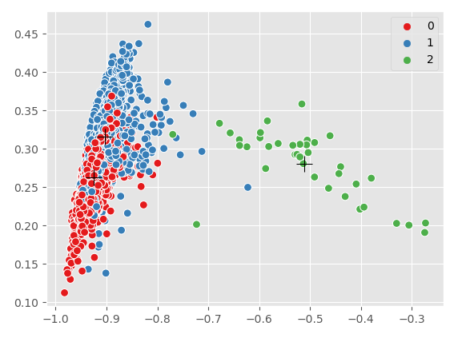

Figure 13: K-means clustering in 2D for audio SVNS dev-clean

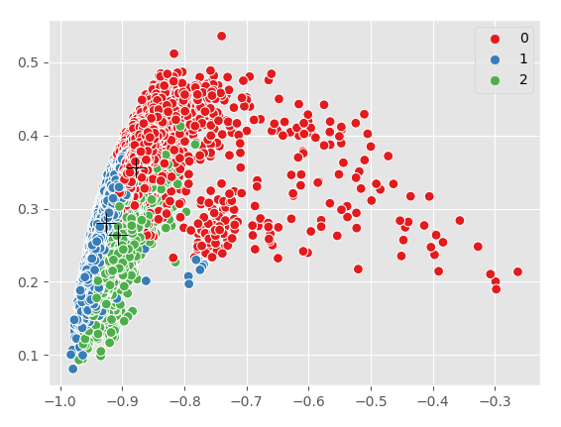

Figure 14: K-means Clustering in 2D for audio SVNS train-clean

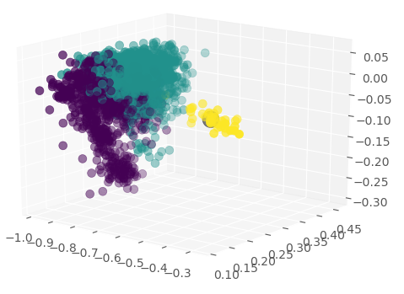

Figure 15: K-means clustering in 3D for audio SVNS dev-clean

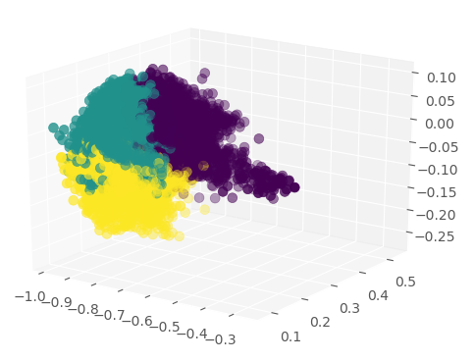

Figure 16: K-means clustering in 3D for audio train clean

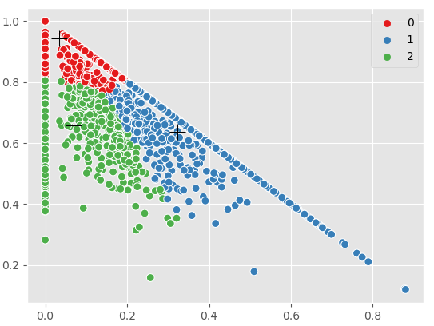

Figure 20: K-means Clustering in 2D for text SVNS dev-clean

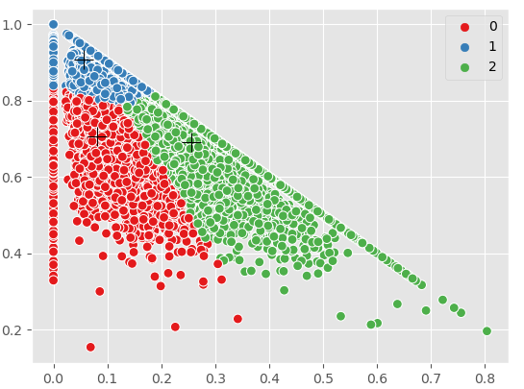

Figure 21: K-means Clustering in 2D for text SVNS train-clean

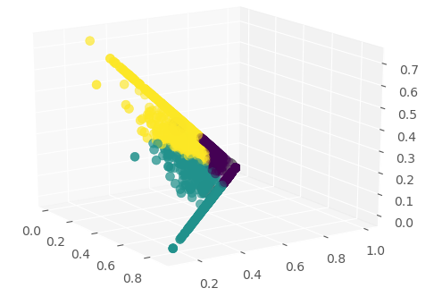

Figure 22: K-means Clustering in 3D for text SVNS dev-clean

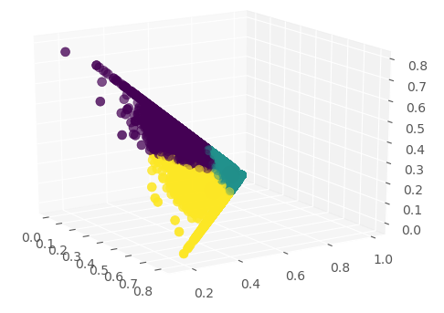

Figure 23: K-means Clustering in 3D for text SVNS train-clean

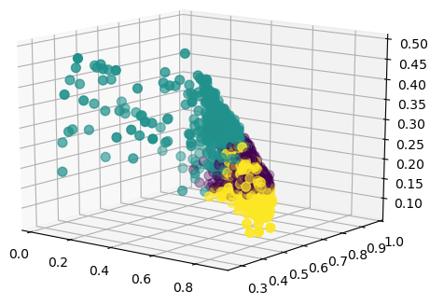

Figure 24: K-means Clustering combined SVNS for dev-clean

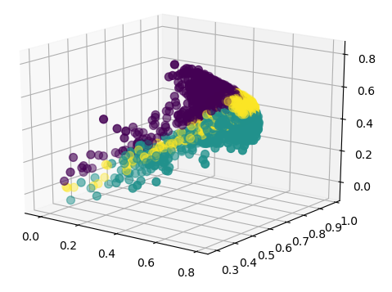

Figure 25: K-means clustering of combined SVNS for train-clean

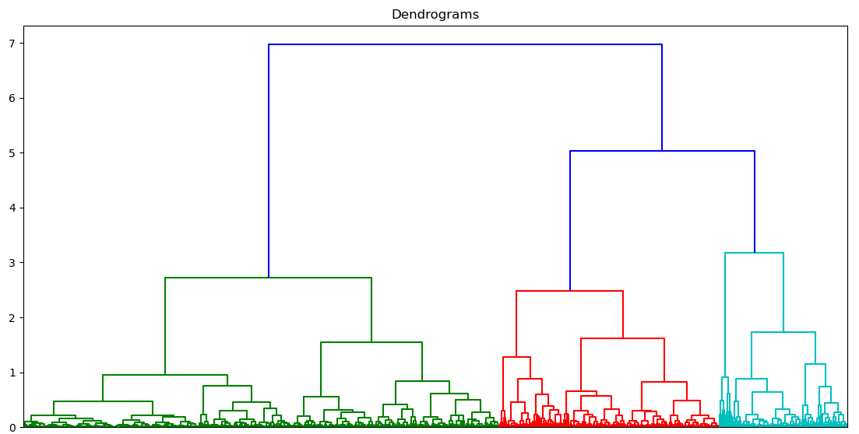

Figure 26: Dendogram of combined SVNS for dev-clean

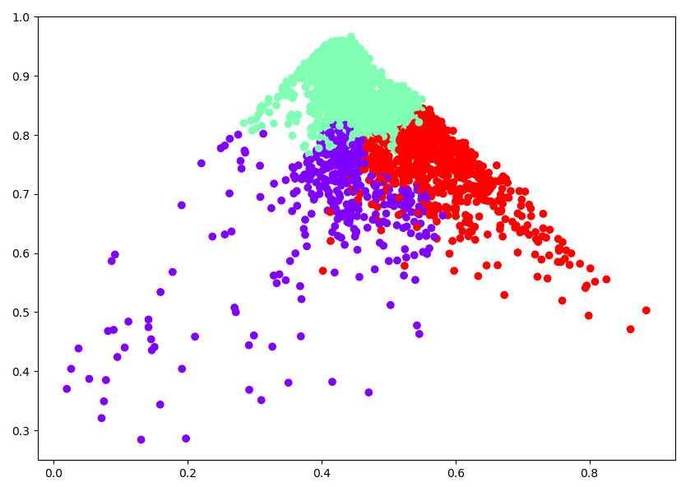

Figure 28: Agglomerative Clustering combined SVNS for dev-clean